**DAILY ONLINE ACTIVITIES SUMMARY**

|  |  |  |  |  |  |  |  |  |
| --- | --- | --- | --- | --- | --- | --- | --- | --- |
| **Date:** | **21-05-2020** | | | | | **Name:** | **Rohan Mahaveer** | |
| **Sem & Sec** | **6th B** | | | | | **USN:** | **4AL17CS077** | |
| **Online Test Summary** | | | | | | | | |
| **Subject** | | **Operating system(OS)** | | | | | | |
| **Max. Marks** | | **30** | | **Score** | | | **30** | |
| **Certification Course Summary** | | | | | | | | |
| **Course** | **Ethical Hacking** | | | | | | | |
| **Certificate Provider** | | | **Alison** | | **Duration** | | | **6hrs** |
| **Coding Challenges** | | | | | | | | |
| Problem Statement: 1. Write C Program to create Singly Liked List with n elements and reverse the elements.  2. Write a C program to construct a singly linked list by removing duplicate elements in the sorted linked list Description: Take a sorted list and traverse the list. Compare the current node element with next adjacent node. If it is same then delete second element, if not retain. Finally print the resulting list. Sample output: Given list {1,2,2,3,3,3,4} Resulting list{1,2,3,4} | | | | | | | | |
| **Status:** YES, Completed all Programs | | | | | | | | |
| **Uploaded the report in Github** | | | | | **YES** | | | |
| **If yes Repository name** | | | | | <https://github.com/rohanmahaveer/daily-status> | | | |
| **Uploaded the report in slack** | | | | | **YES** | | | |

Online Test Details:

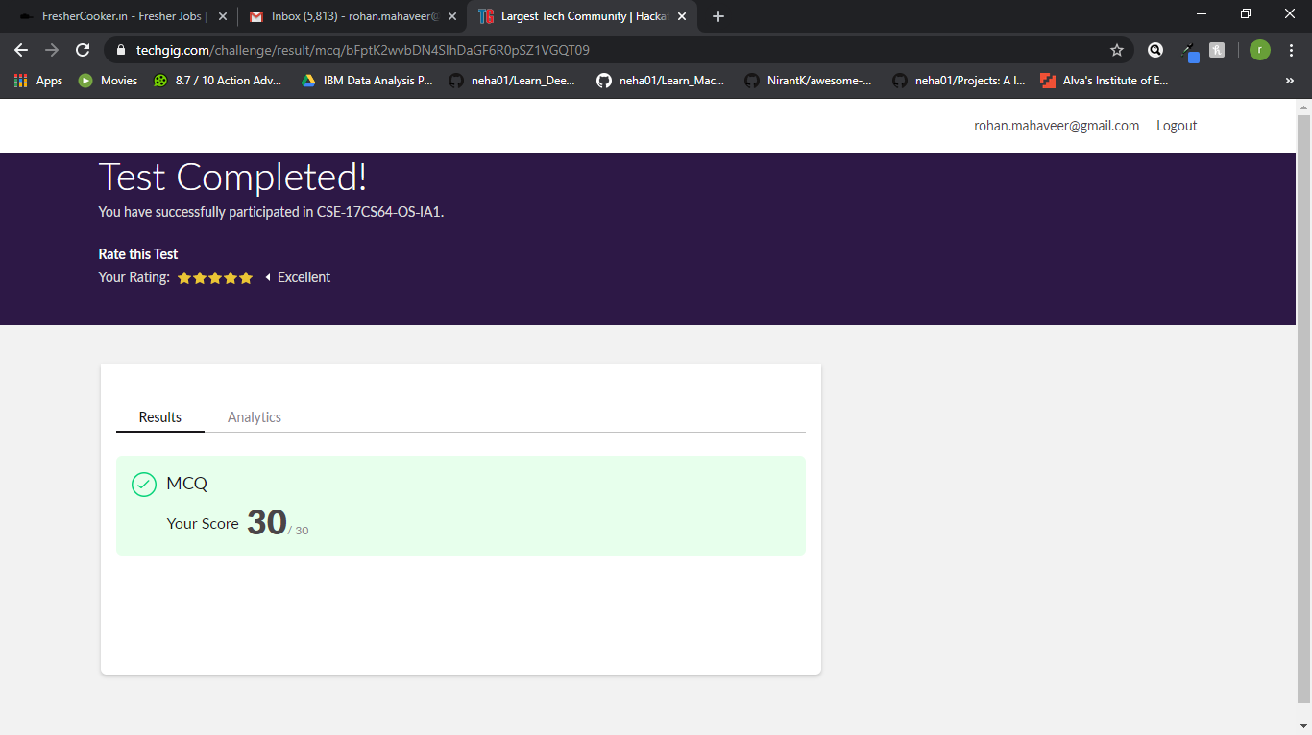

Scored 30 out of 30 in OS 1st I.A test

Certification Course Details:

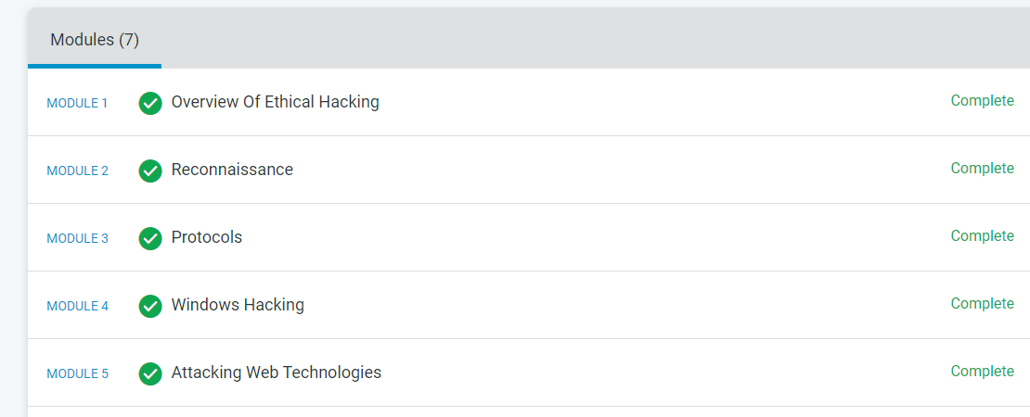

The above course is being taken up by me is based on Ethical hacking. It started with the CIA triad, today in online course I studied about SQL injection, misconfiguration software, broken authentication and how to prevent this types of attack. The details of the course and certificate provider are mentioned in the above form.

Coding Challenges Details:

Program1:

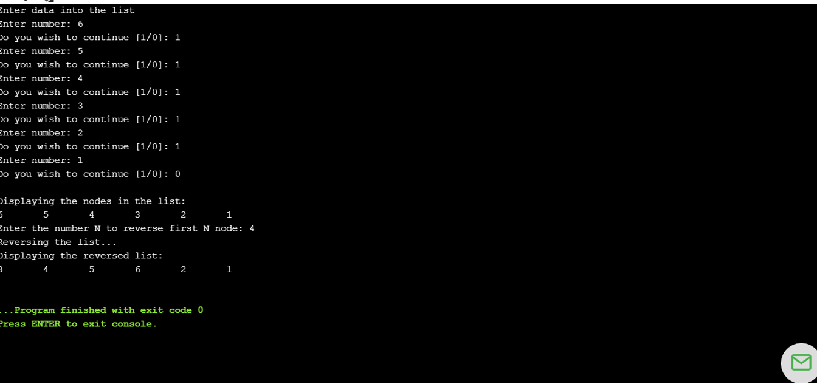

Program2:

